# Analysis of Alternatives AOA

Analysis of Alternatives is the evaluation of the different choices available to achieve a particular [project management](https://project-management-knowledge.com/definitions/p/project-management-pm/) objective. It is an analytical comparison of different factors like operational cost, risks, effectiveness as well as the shortfalls in an operational capability. It requires different tools such as life-cycle costing, sensitivity analysis, and cost-benefit analysis. With alternative analysis, options to the solution are identified to satisfy the needs of an existing or new program.

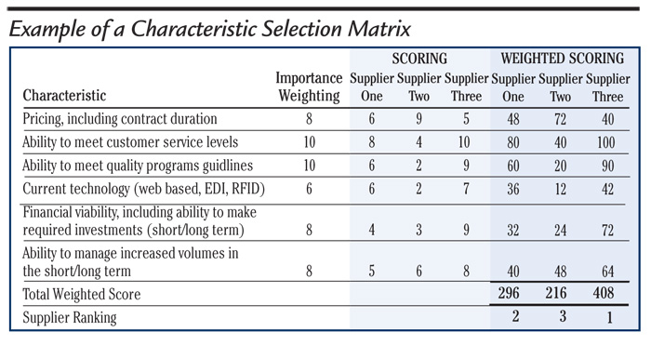

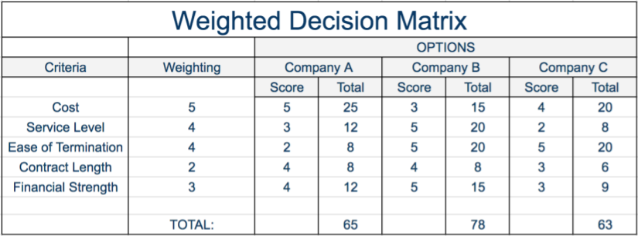

Typical steps in an AoA include:

* **Plan:** Define decision/objectives supported, identify stakeholders, define the schedule/funding/effort, establish the study team, prepare the study plan.
* **Establish analysis foundation/framework:** Define the analysis problem statement, context, scope, and framework for alternative comparison, including criteria to be used. Establish ground rules and assumptions that frame the analysis. Address data needs, collection, and sources prior to and during the study.
* **Identify and define alternatives:** Identify multiple alternatives (one of which could be to maintain the "status quo") that address the stated problem within the context and scope defined. The final set of alternatives evaluated should be the product of thorough research, vetting, and filtering.
* **Assess alternatives:** Evaluate each alternative against established criteria (e.g., cost, risk, effectiveness/benefit); conduct sensitivity analysis.
* **Compare alternatives:** Determine the relative merits of the alternatives as exposed by the analysis.
* **Report results:** Document results that support decision-maker/stakeholder needs.